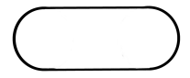
- A farmer is going to use fence to make a pen shaped like cutting a circle in half and inserting a rectangle (like in the picture below).

If the pen is to have an area of , how should he make the pen to minimize the amount of fence needed? Find all dimensions of the pen and sketch a picture of it.

- For each , a triangle is formed with vertices and where is the function given below. What is the value of x which results in the triangle of largest area? What is this largest area?

- A rectangular box, without a top, is to be made by cutting squares out of corners of a sheet of carboard and folding up the sides (like in the diagram below). Find the maximum volume of such a box from a sheet measuring 4 meters by 4 meters.
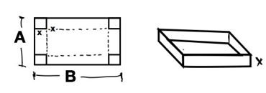


- A rectangular box, without a top, is to be made by cutting squares out of corners of a sheet of carboard and folding up the sides (like in the diagram below). Show that the maximum volume of such a box from a sheet measuring A meters by B meters occurs when the squares cut out have side lengths

- A cone-shaped drinking cup is made from a cicular piece of paper of radius R by cutting out a sector and joining the edges of CA and CB. Find the angle that is needed in order to maximize the capacity of such a cup.
